Chapter 1.3.2 Using Cloud Pub/Sub

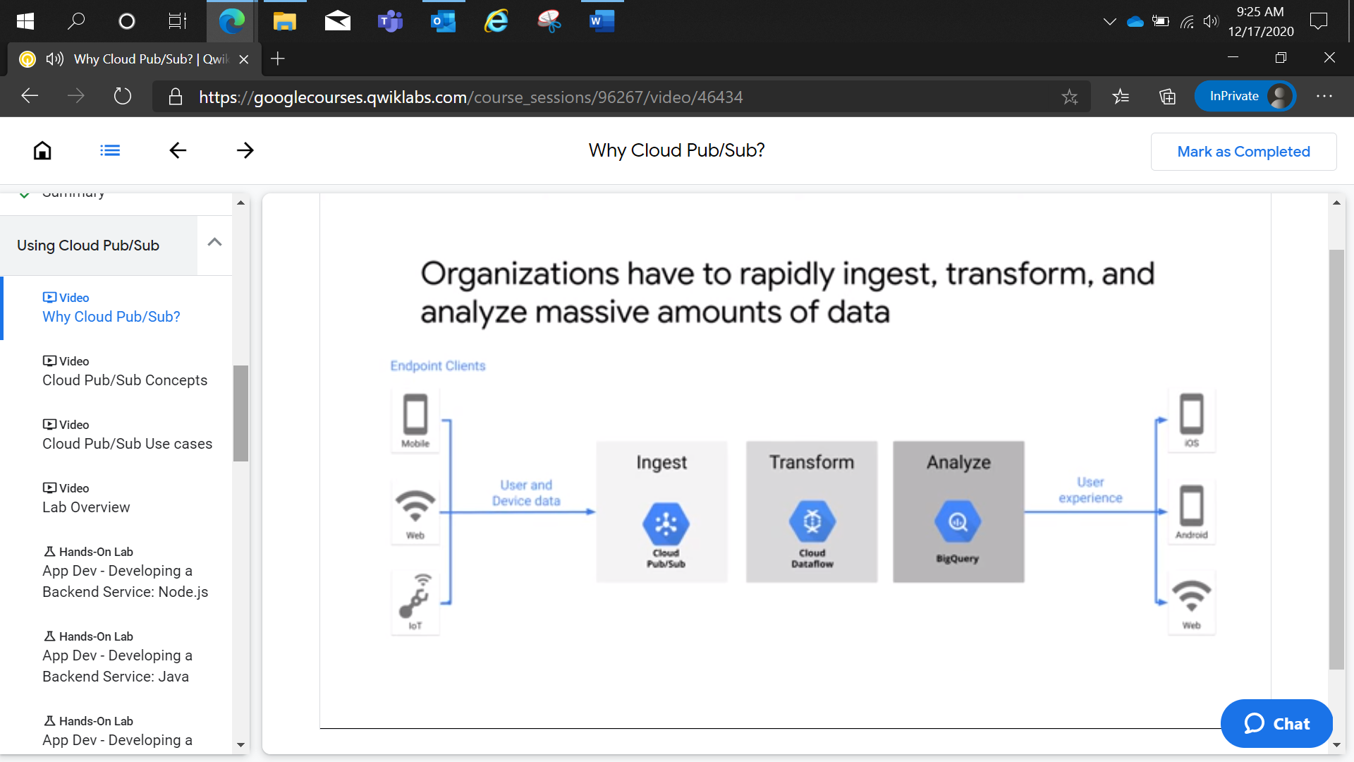

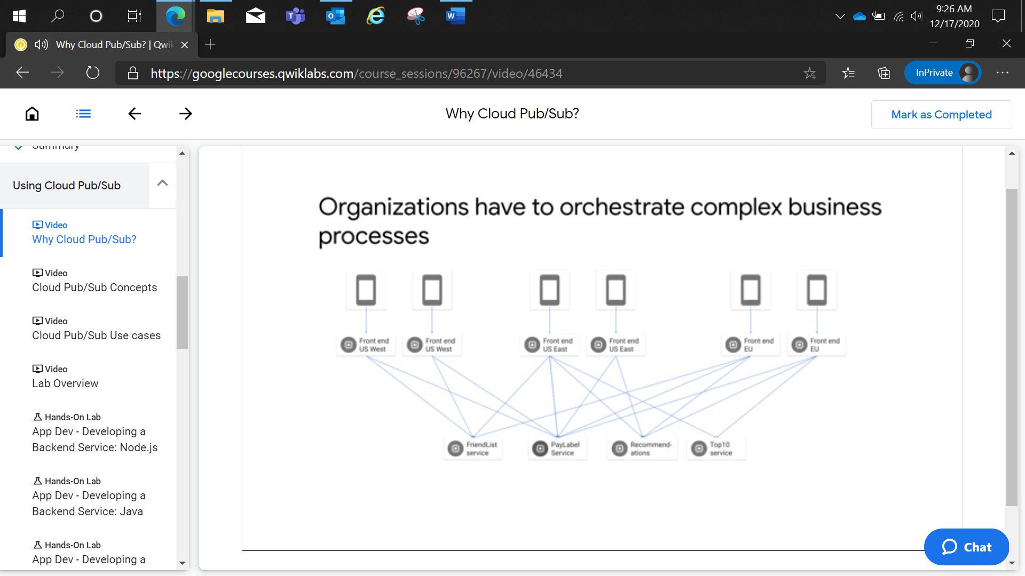

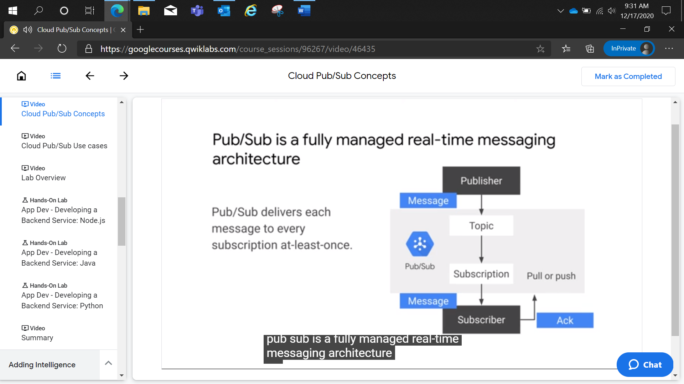

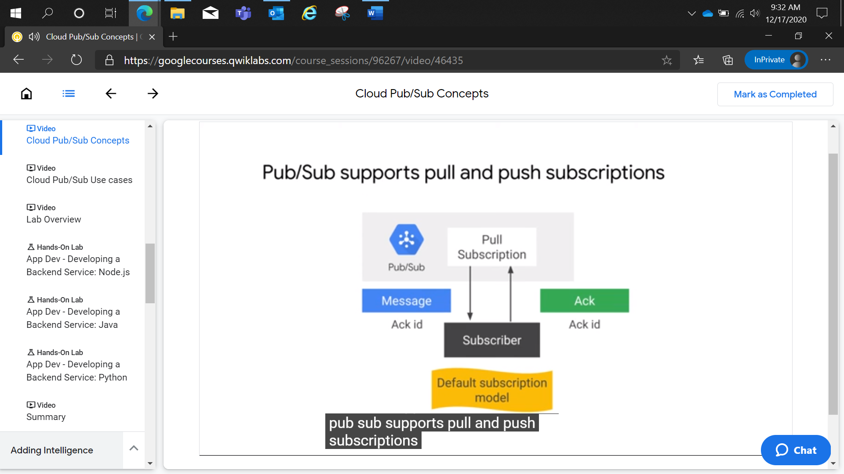

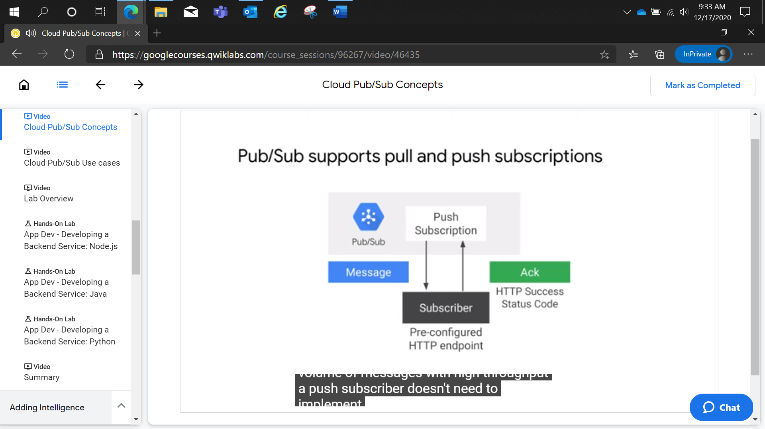

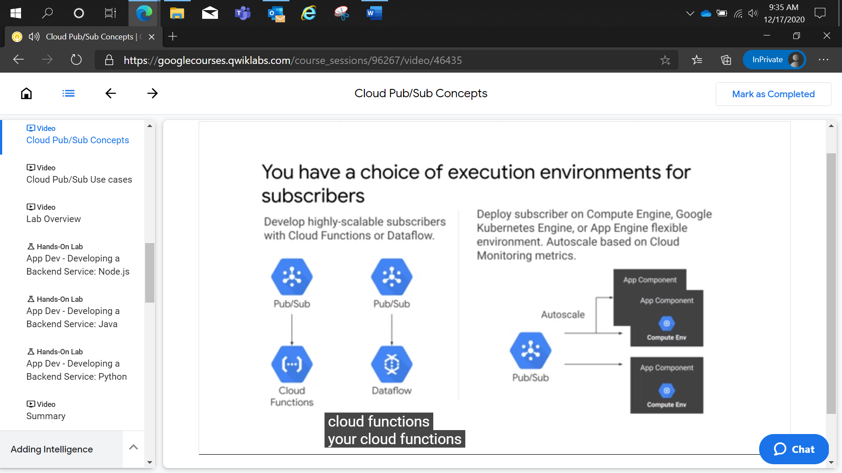

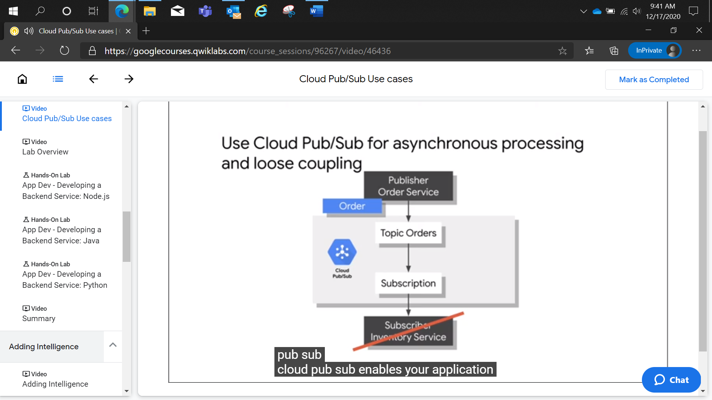

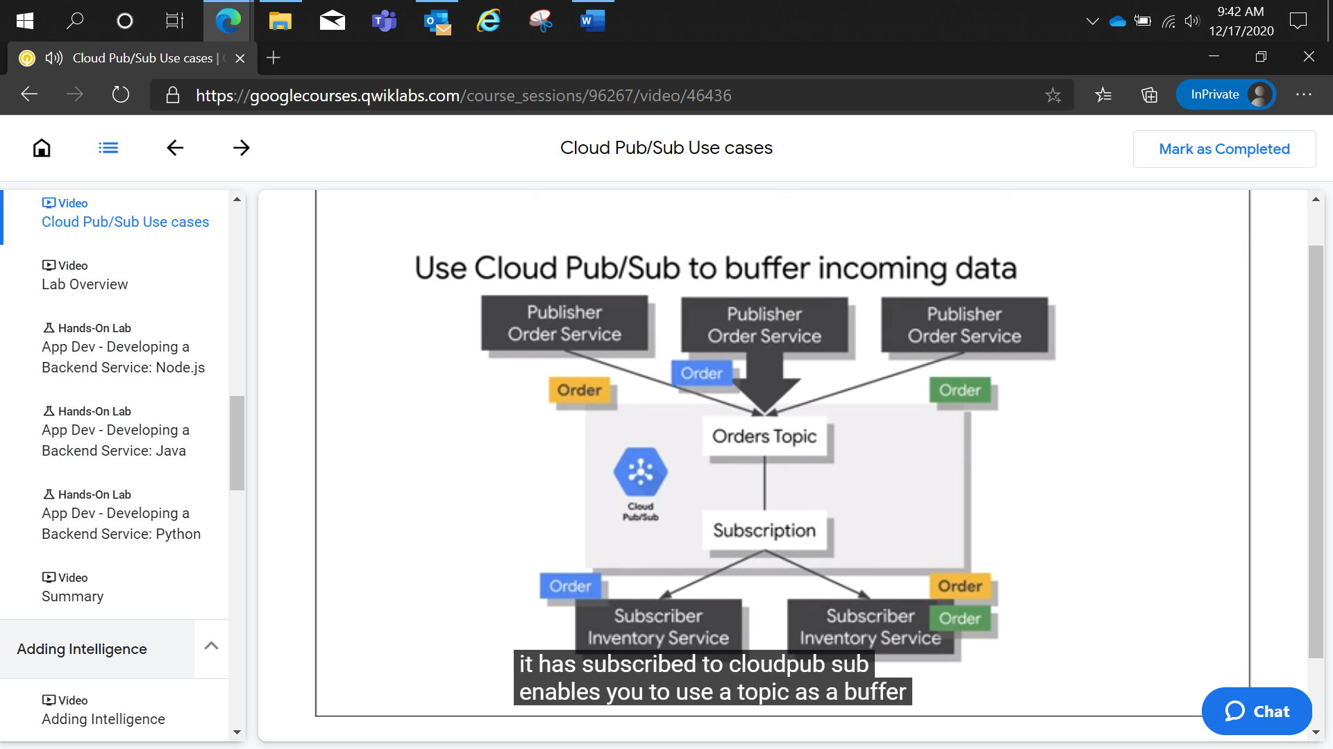

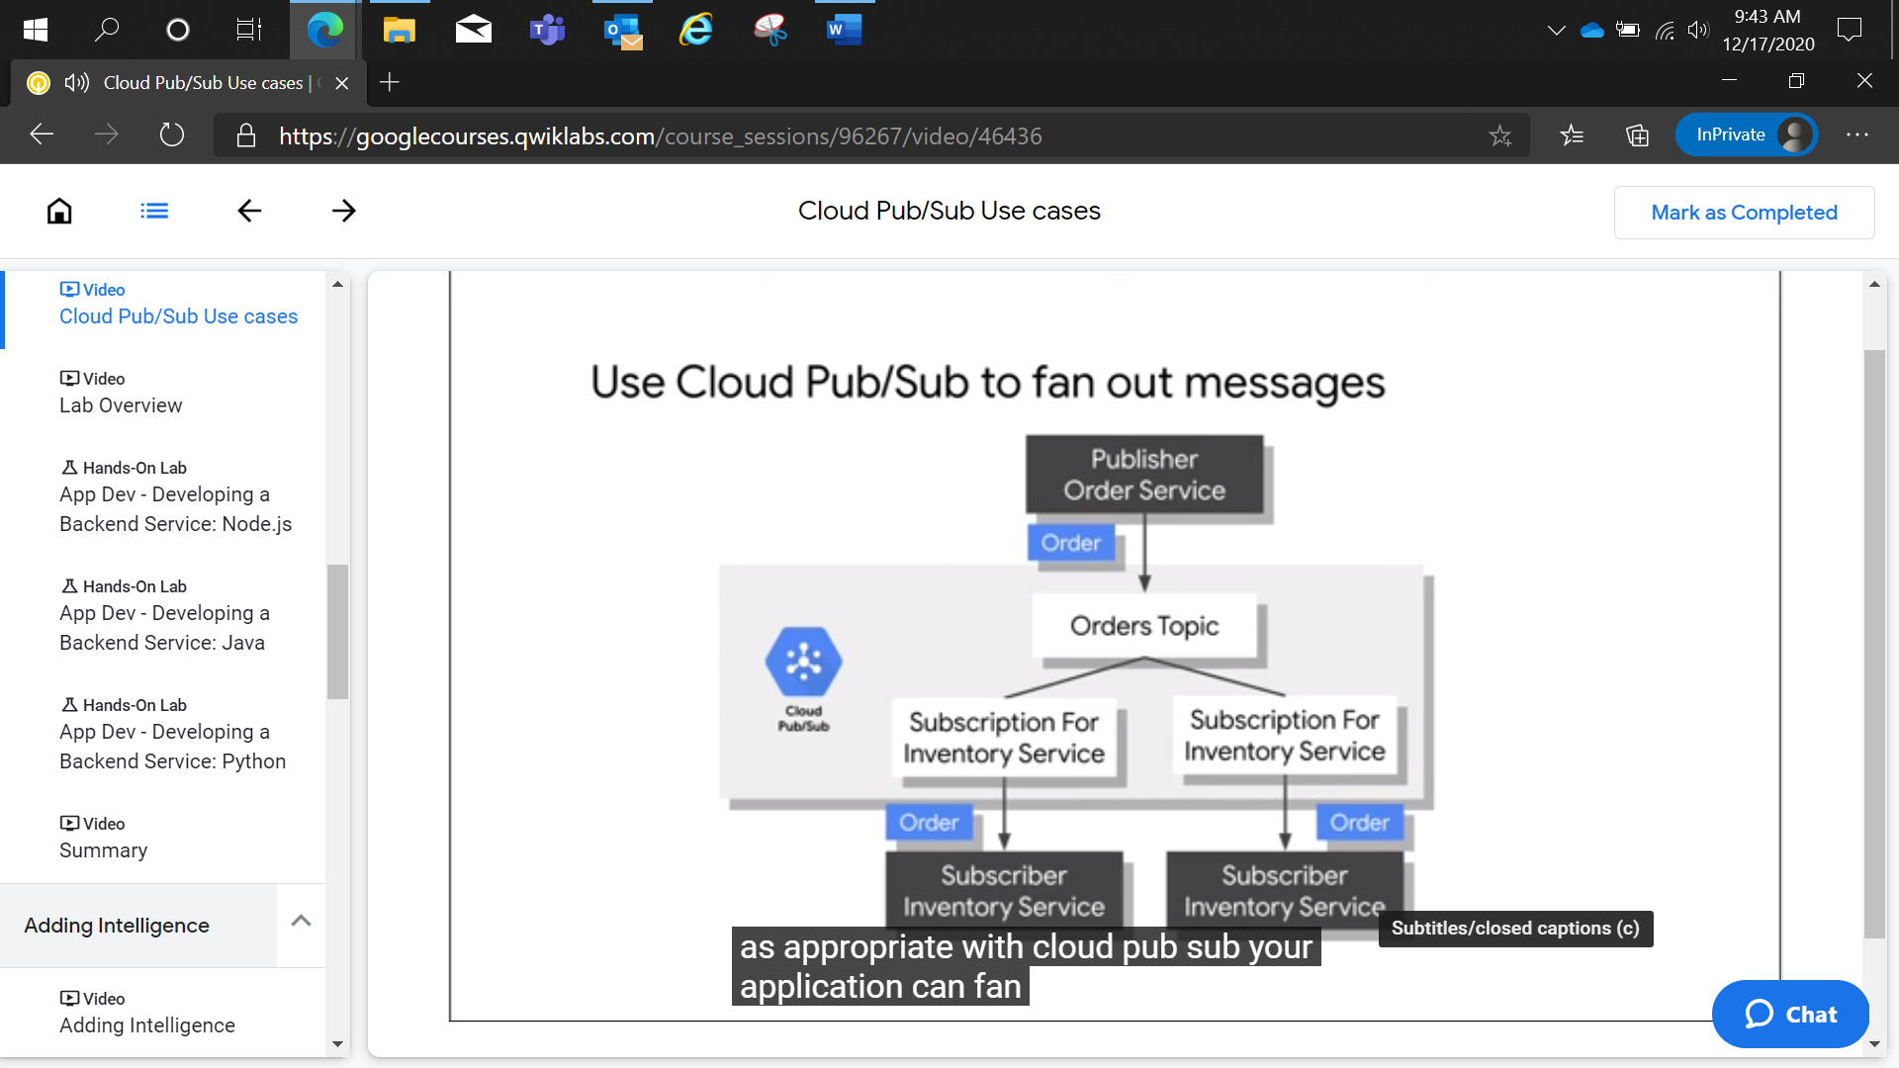

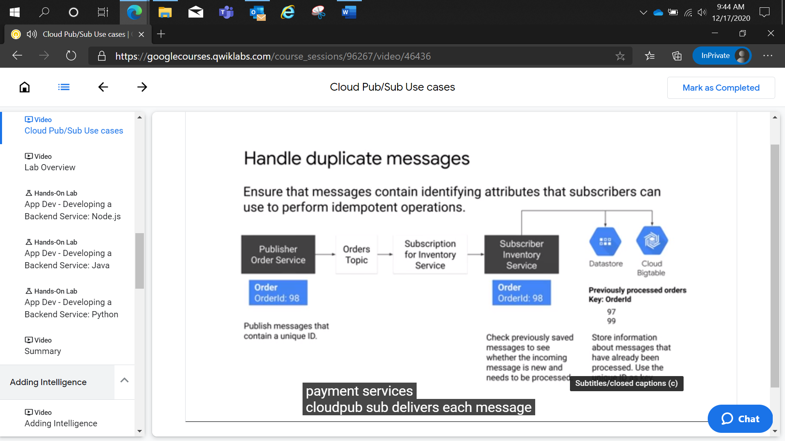

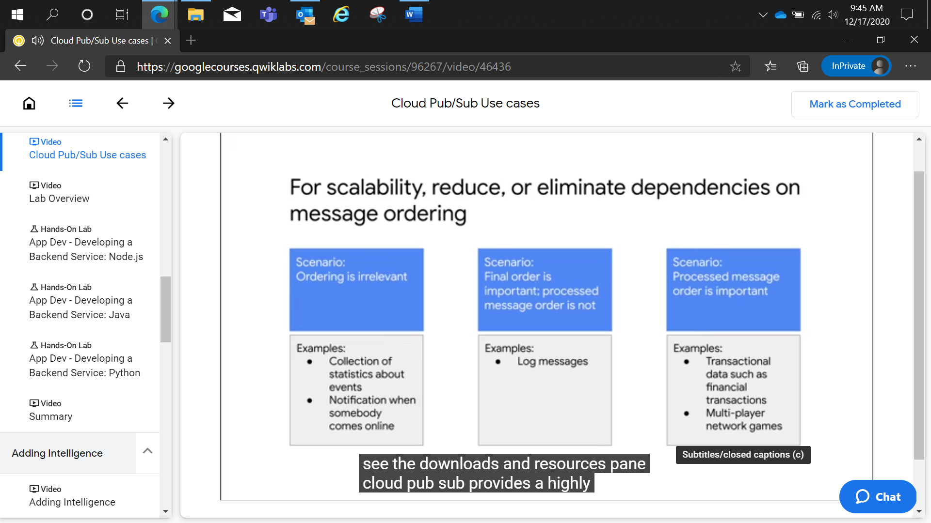

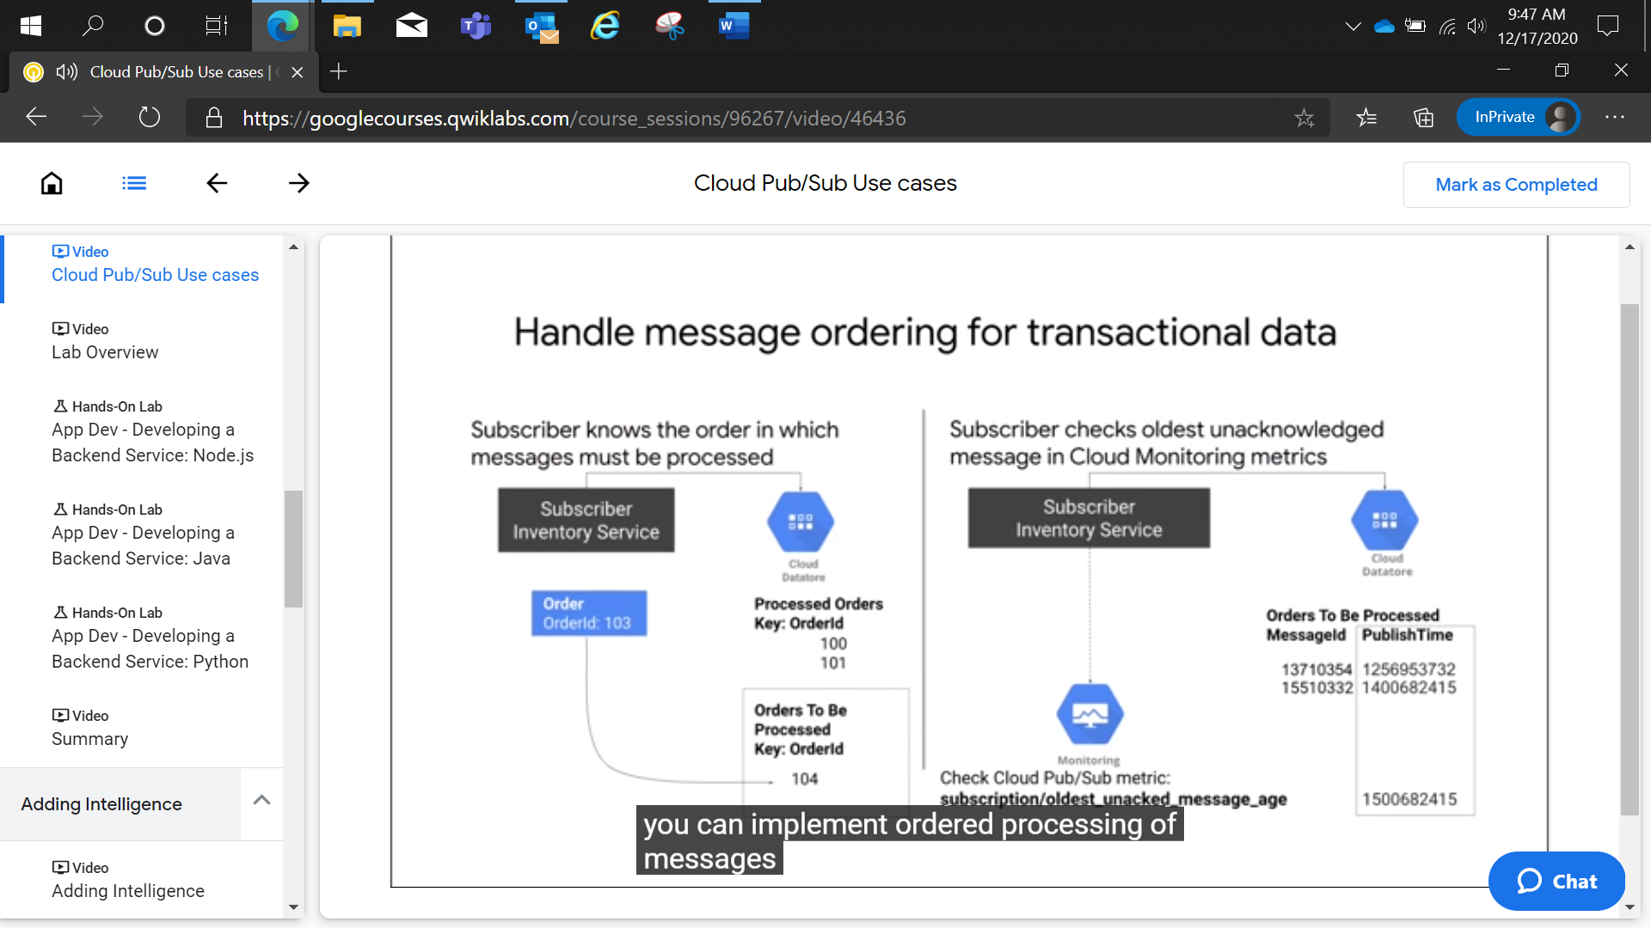

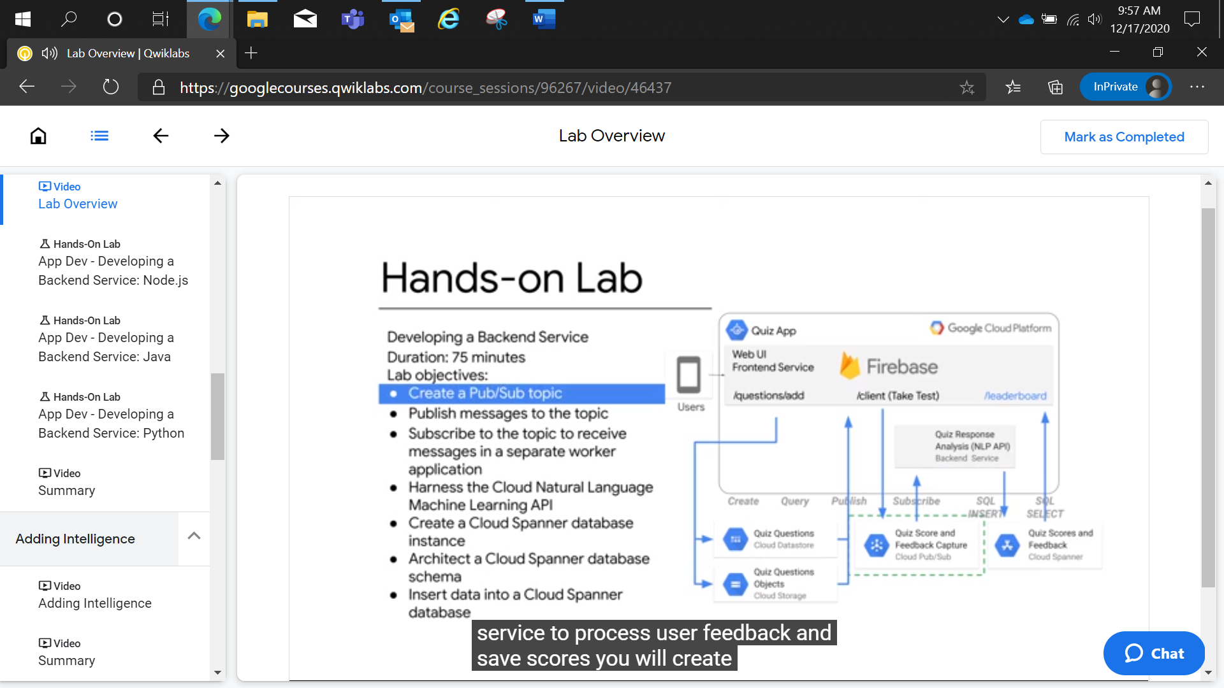

App Dev - Developing a Backend Service: Java

2 hoursFree

Rate Lab

**Overview**

In this lab, you develop a backend service for an online Quiz application to process user feedback and save scores.

The Quiz application has two parts, the web application that will run in the first Cloud shell window and the worker application that runs in the second Cloud Shell window.

* Web application: manages the logic of sending the user's feedback to a pub/sub topic.
* Worker application: listens to the feedback provided by the user to eventually perform sentiment analysis and store them in a database (Cloud Spanner).

This process takes advantage of Google Cloud Platform (GCP) products and services:

* Cloud Pub/Sub: The Topic alerts and provides the subscribing worker application to new scores and feedback for analysis.
* Cloud Natural Language: Provides sentiment analysis on the feedback.
* Cloud Spanner: Database for the Quiz application.

**Objectives**

In this lab, you will learn how to perform the following tasks:

* Create and publish messages to a Cloud Pub/Sub topic.
* Subscribe to the topic to receive messages in a separate worker application.
* Perform sentiment analysis on feedback.
* Create a Cloud Spanner database instance and schema, then insert data into the database.

**Setup and requirements**

**Lab setup**

For each lab, you get a new GCP project and set of resources for a fixed time at no cost.

1. Make sure you signed into Qwiklabs using an **incognito window**.
2. Note the lab's access time (for example, 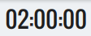 and make sure you can finish in that time block.

There is no pause feature. You can restart if needed, but you have to start at the beginning.

1. When ready, click .
2. Note your lab credentials. You will use them to sign in to Cloud Platform Console. 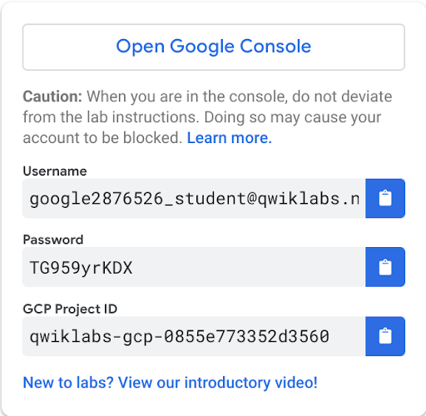
3. Click **Open Google Console**.
4. Click **Use another account** and copy/paste credentials for **this** lab into the prompts.

If you use other credentials, you'll get errors or **incur charges**.

1. Accept the terms and skip the recovery resource page.

Do not click **End Lab** unless you are finished with the lab or want to restart it. This clears your work and removes the project.

Activate Google Cloud Shell

Google Cloud Shell is a virtual machine that is loaded with development tools. It offers a persistent 5GB home directory and runs on the Google Cloud. Google Cloud Shell provides command-line access to your GCP resources.

1. In GCP console, on the top right toolbar, click the Open Cloud Shell button.

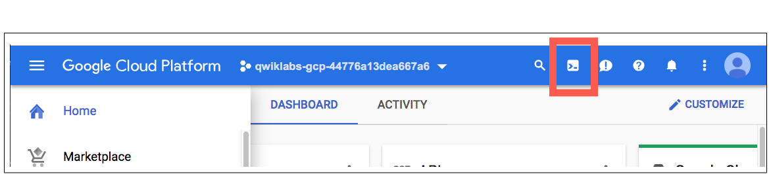

1. Click **Continue**. 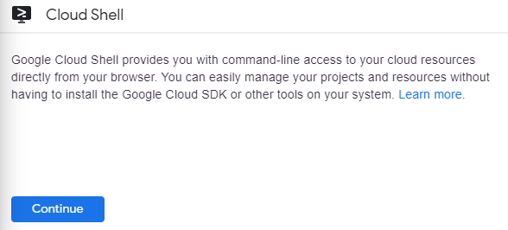

It takes a few moments to provision and connect to the environment. When you are connected, you are already authenticated, and the project is set to your *PROJECT_ID*. For example:

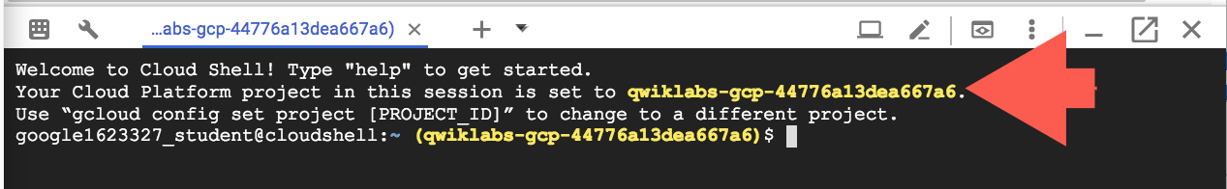

**gcloud** is the command-line tool for Google Cloud Platform. It comes pre-installed on Cloud Shell and supports tab-completion.

You can list the active account name with this command:

gcloud auth list

content_copy

Output:

Credentialed accounts:

- <myaccount>@<mydomain>.com (active)content_copy

Example output:

Credentialed accounts:

- google1623327_student@qwiklabs.netcontent_copy

You can list the project ID with this command:

gcloud config list project

content_copy

Output:

[core]

project = <project_ID>content_copy

Example output:

[core]

project = qwiklabs-gcp-44776a13dea667a6content_copy

Full documentation of **gcloud** is available on [Google Cloud gcloud Overview](https://cloud.google.com/sdk/gcloud).

**Prepare the Quiz application**

In this section, you access Cloud Shell, clone the git repository containing the Quiz application, configure environment variables, and run the application.

Clone source code in Cloud Shell

1. Enter the following command to clone the repository for the class:

git clone https://github.com/GoogleCloudPlatform/training-data-analyst

content_copy

1. Create a soft link to your working directory:

ln -s ~/training-data-analyst/courses/developingapps/v1.2/java/pubsub-languageapi-spanner ~/pubsub-languageapi-spannercontent_copy

Set up the web application

In this section you'll configure dependencies and run the web application.

1. Navigate to the directory that contains the sample files for this lab:
2. cd ~/pubsub-languageapi-spanner/start

content_copy

1. Configure the web application:
2. . prepare_web_environment.sh

content_copy

This script file:

* + Creates an App Engine application.
  + Exports environment variables: GCLOUD_PROJECT and GCLOUD_BUCKET.
  + Runs mvn clean install.
  + Creates entities in Cloud Datastore.
  + Prints out the GCP Project ID.

You can run this application when you see output similar to the following:

[INFO] ------------------------------------------------------------------------

[INFO] BUILD SUCCESS

[INFO] ------------------------------------------------------------------------

[INFO] Total time: 8.979 s

[INFO] Finished at: 2018-05-28T22:02:26-04:00

[INFO] ------------------------------------------------------------------------

Project ID: qwiklabs-gcp-198243c75d5ac1b7

content_copy

1. Run the web application:
2. mvn spring-boot:run

content_copy

The application is running when you see you see output similar to the following.

00:13:09.089 [restartedMain] INFO c.g.training.appdev.QuizApplication - Started QuizApplication in 10.434 seconds (JVM running for 11.351)

content_copy

Set up the worker application

1. Click **Add Cloud Shell session** (**+**) on the right of the Cloud Shell tab to open a second Cloud Shell window. Enter the following command to change the working directory:
2. cd ~/pubsub-languageapi-spanner/start

content_copy

1. Prepare the environment in the second Cloud Shell window:
2. . prepare_worker_environment.sh

content_copy

This script file:

* + Exports environment variables GCLOUD_PROJECT and GCLOUD_BUCKET.
  + Creates and configures a GCP Service Account.
  + Prints out the Google Cloud Platform Project ID.

1. Now start the worker application:
2. mvn exec:java@worker

content_copy

Review the Quiz application

1. Still in the second Cloud Shell window, click **Web preview** > **Preview on port 8080** to preview the Quiz application.

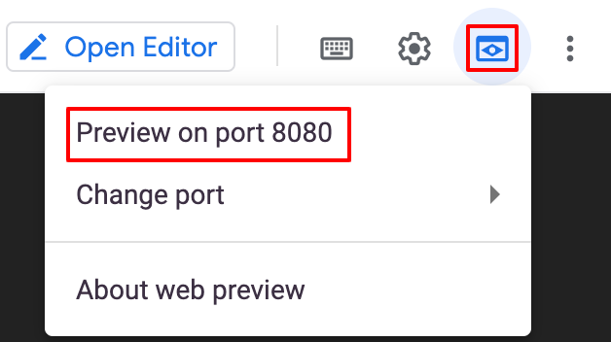

1. In the navigation bar, click **Take Test**.

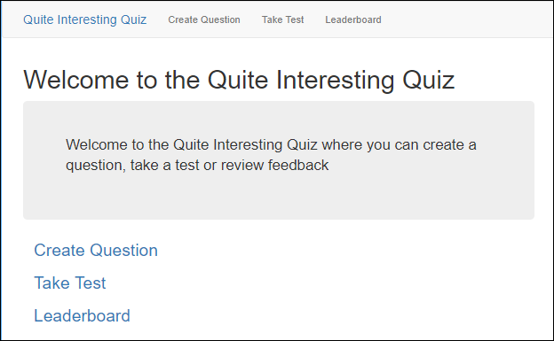

1. Click **Places**.

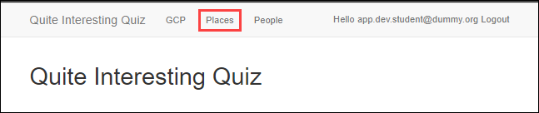

1. Answer the question.

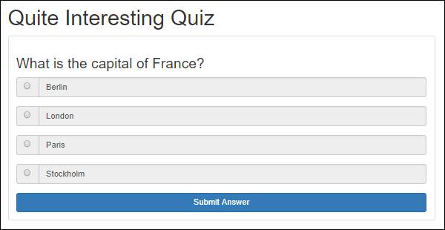

After you answer the question, you should see a final screen inviting you to submit feedback.

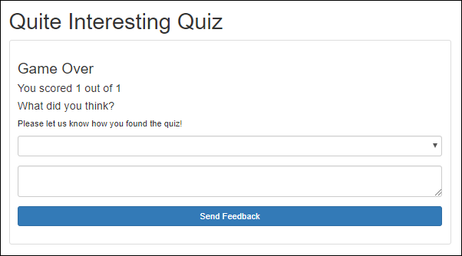

Quiz takers can select a rating and enter feedback.

1. Return Cloud Shell. Press **Ctrl**+**c** in the first and second windows to stop the web and worker applications.

**Examine the Quiz Application Code**

In this section you examine the file structure and the files that impact the Quiz application.

In this lab you'll view and edit files. You can use the shell editors that are installed on Cloud Shell, such as nano or vim, or use the Cloud Shell code editor. This lab uses the Cloud Shell code editor.

Launch the Cloud Shell Editor

In the **Cloud Shell**, click **Open Editor**.

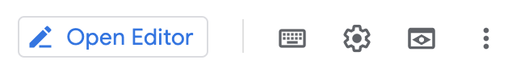

Review the GCP application code structure

Navigate to the /pubsub-languageapi-spanner/start folder using the file browser panel on the left side of the editor.

Now expand the /src/main/java/com/google/training/appdev folder. All Java code paths are relative to this folder.

Select the Feedback.java file in the .../services/gcp/domain folder.

This file contains a model class that represents the feedback submitted by quiz takers.

Select the PublishService.java file in the .../services/gcp/pubsub folder.

This file contains a service class that allows applications to publish feedback messages to a Cloud Pub/Sub topic.

Select the LanguageService.java file in the .../services/gcp/languageapi folder. This file contains a service class that allows users to send text to the Cloud Natural Language ML API and to receive the sentiment score from the API.

Select the SpannerService.java file in the .../services/gcp/spanner folder.

This file contains a service class that allows users to save the feedback and Natural Language API response data in a Cloud Spanner database instance.

Review the web and backend application code

Select the QuizEndpoint.java file in the .../apifolder.

The handler for POST messages sent to the /api/quizzes/feedback/:quiz route publishes the feedback data received from the client to Pub/Sub.

Select the ConsoleApp.java file in the .../backend folder.

This file runs as a separate console application to consume the messages delivered to a Pub/Sub subscription.

**Working with Cloud Pub/Sub**

The Quiz application uses a Pub/Sub function to retrieve answers and feedback that a user inputs through the quiz interface.

In this section, you create a Cloud Pub/Sub topic and subscription in your GCP project, then publish and retrieve a message.

Create a Cloud Pub/Sub topic

1. In the Console, click **Navigation menu** > **Pub/Sub** > **Topics,** and then click **Create topic**.

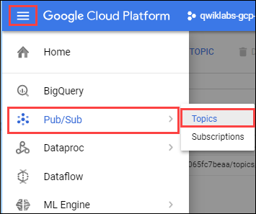

1. Set the Topic ID to feedback, and then click **CREATE TOPIC**.

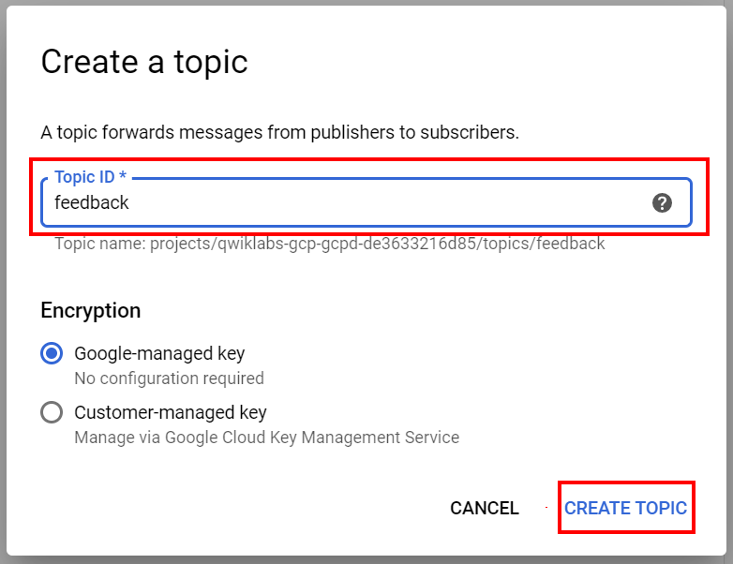

The Topic details view opens:

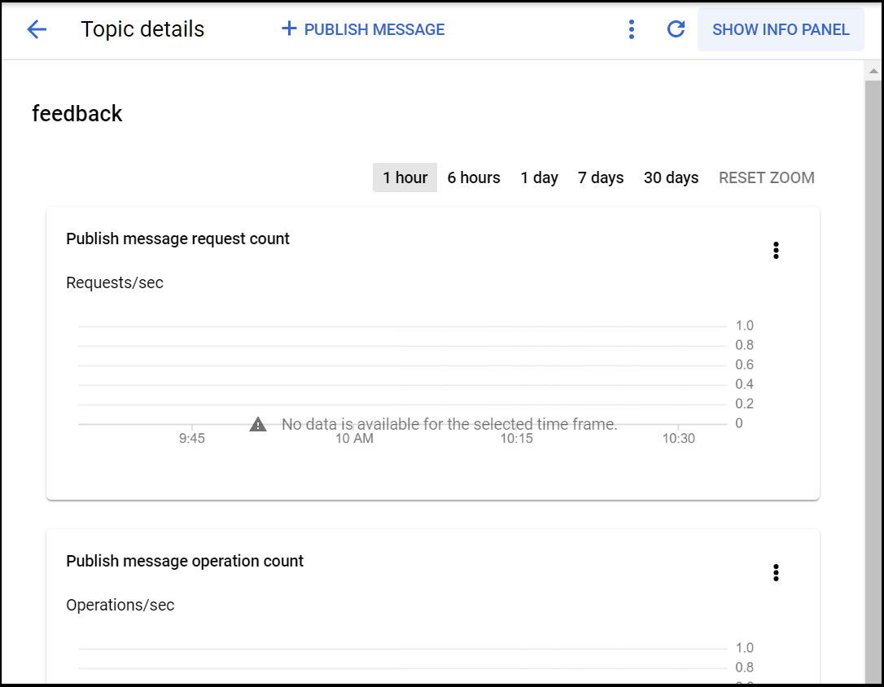

Create a Cloud Pub/Sub subscription

Return to the second Cloud Shell window.

Enter the following command to create a Cloud Pub/Sub subscription named cloud-shell-subscription against the feedback topic:

gcloud pubsub subscriptions create cloud-shell-subscription --topic feedback

content_copy

If you receive an error about the active account not having valid credentials, wait for a minute and try the command again.

Publish a message to a Cloud Pub/Sub topic

Publish a "Hello World" message into the feedback topic in the second Cloud Shell window:

gcloud pubsub topics publish feedback --message="Hello World"

content_copy

Retrieve a message from a Cloud Pub/Sub subscription

To pull the message from the feedback topic with automatic acknowledgement of the message in the second Cloud Shell window:

gcloud pubsub subscriptions pull cloud-shell-subscription --auto-ack

content_copy

Output:

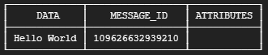

**Publish Messages to Cloud Pub/Sub Programmatically**

In this section, you write code to publish messages to Cloud Pub/Sub.

**Important**: Update code within the sections marked as follows:

// TODO

// END TODO

To maximize your learning, review the code, inline comments, and related API documentation.

Publish a Pub/Sub message

Open the .../services/gcp/pubsub/PublishService.java file in the code editor. Update the file by adding code as directed.

1. Declare two static final strings for the PROJECT_ID and TOPIC_NAME.
2. // TODO: Declare and initialize two Strings,
3. // PROJECT_ID and TOPIC_NAME
4. private static final String PROJECT_ID =
5. ServiceOptions.getDefaultProjectId();
6. private static final String TOPIC_NAME = "feedback";
7. // END TODO

content_copy

1. Move to the publishFeedback(...) method. Create a TopicName object using the PROJECT_ID and TOPIC_NAME strings.

The topic name references the Cloud Pub/Sub topic you just created.

// TODO: Create a TopicName object

// for the feedback topic in the project

TopicName topicName =

TopicName.create(PROJECT_ID, TOPIC_NAME);

// END TODO

content_copy

1. Declare a Publisher object and set it to null. It will be initialized in the try block that follows.
2. // TODO: Declare a publisher for the topic
3. Publisher publisher = null;
4. // END TODO

content_copy

1. Move to the try block, and initialize the publisher object using its builder.
2. // TODO: Initialize the publisher
3. // using a builder and the topicName
4. publisher = Publisher.defaultBuilder(topicName).build();
5. // END TODO

content_copy

1. Copy the JSON serialized feedbackMessage string to a ByteString.
2. // TODO: Copy the serialized message
3. // to a byte string
4. ByteString data = ByteString.copyFromUtf8(
5. feedbackMessage);
6. // END TODO

content_copy

1. Declare a PubsubMessage object; initialize the message using its builder.
2. // TODO: Create a Pub/Sub message using a
3. // builder; set the message data
4. PubsubMessage pubsubMessage = PubsubMessage
5. .newBuilder().setData(data).build();
6. // END TODO

content_copy

1. Use the publisher to publish the message, assign the return value to the message ID future object.
2. // TODO: Publish the message,
3. // assign to the messageIdFuture
4. messageIdFuture = publisher.publish(
5. pubsubMessage);
6. // END TODO

content_copy

1. Move to the finally block and retrieve the Pub/Sub messageId from the message ID future object.
2. // TODO: Get the messageId from
3. // the messageIdFuture
4. String messageId = messageIdFuture.get();
5. // END TODO

content_copy

1. Complete the publishing code by shutting down the publisher.
2. // TODO: Shutdown the publisher
3. // to free up resources
4. if (publisher != null) {
5. publisher.shutdown();
6. }
7. // END TODO

content_copy

1. Save services/gcp/pubsub/PublishService.java .

Write code to use the Pub/Sub publish functionality

1. In the .../api/QuizEndpoint.java file, declare a new PublishService field named publishService. Apply the Spring @Autowired annotation.
2. // TODO: Declare the publishService
3. @Autowired
4. private PublishService publishService;
5. // END TODO

content_copy

1. In the processFeedback(...) method that handles POST requests to the '/feedback/:quiz' route, invoke the publishService.publishFeedback(feedback) method.
2. // TODO: Publish the feedback to Pub/Sub
3. publishService.publishFeedback(feedback);
4. // END TODO

content_copy

1. Save /api/QuizEndpoint.java.

Run the application and create a Pub/Sub message

1. In the first Cloud Shell window, restart the web application (if it is running, stop and start it).
2. mvn spring-boot:run

content_copy

1. Preview the web application, click **Take Test** > **Places**.
2. Answer the question, select the rating, enter some feedback text, and click **Send Feedback**.
3. In the second Cloud Shell window, to pull a message from the cloud-shell-subscription:
4. gcloud pubsub subscriptions pull cloud-shell-subscription --auto-ack

content_copy

**Subscribing to Cloud Pub/Sub Topics Programmatically**

In this section you write the code to create a subscription and receive message notifications from a Cloud Pub/Sub topic to the worker application.

Write code to create a Cloud Pub/Sub subscription and receive messages

In the code editor open the ...backend/ConsoleApp.java file. Update the file by adding code as directed.

Skip over the **TODO** blocks for languageService and spannerService. You'll return for those later.

1. In the main()method, create a SubscriptionName object representing a new subscription named "worker1-subscription".
2. // TODO: Create the Pub/Sub subscription name
3. SubscriptionName subscription =
4. SubscriptionName.create(projectId,
5. "worker1-subscription");
6. // END TODO

content_copy

1. Create a SubscriptionAdminClient object using a try block.

Also in the try block, use the subscription admin client to create a new subscription against the feedback topic. Don't forget the close brace.

// TODO: Create the subscriptionAdminClient

try (SubscriptionAdminClient subscriptionAdminClient =

SubscriptionAdminClient.create()) {

// TODO: create the Pub/Sub subscription

// using the subscription name and topic

subscriptionAdminClient.createSubscription(

subscription, topic,

PushConfig.getDefaultInstance(), 0);

// END TODO

}

// END TODO

content_copy

1. Move to the code that creates a MessageReceiver, and in the receiveMessage(...) override, extract the message data into a String.
2. // TODO: Extract the message data as a JSON String
3. String fb = message.getData().toStringUtf8();
4. // END TODO

content_copy

1. Use the consumer to acknowledge the message.
2. // TODO: Ack the message
3. consumer.ack();
4. // END TODO

content_copy

1. After the code that initializes an ObjectMapper, deserialize the JSON String message data into a feedback object.
2. // TODO: Deserialize the JSON String
3. // representing the feedback
4. // Print out the feedback
5. Feedback feedback = mapper.readValue(
6. fb, Feedback.class);
7. System.out.println("Feedback received: "
8. + feedback);
9. // END TODO

content_copy

1. After the block that creates the MessageReceiver, declare a Subscriber and initialize it to null.

Skip over a few **TODO** blocks and look for this one.

// TODO: Declare a subscriber

Subscriber subscriber = null;

// END TODO

content_copy

1. Move to the try block, and initialize the Subscriber using its default builder. This requires the subscription and receiver.
2. // TODO: Initialize the subscriber using
3. // its default builder
4. // with a subscription and receiver
5. subscriber = Subscriber.defaultBuilder(
6. subscription, receiver).build();
7. // END TODO

content_copy

1. Add a listener to the subscriber to display errors.
2. // TODO: Add a listener to the subscriber
3. subscriber.addListener(
4. new Subscriber.Listener() {
5. @Override
6. public void failed(
7. Subscriber.State from,
8. Throwable failure) {
9. System.err.println(failure);
10. }
11. },
12. MoreExecutors.directExecutor());
13. // END TODO

content_copy

1. Start the subscriber.
2. // TODO: Start subscribing
3. subscriber.startAsync().awaitRunning();
4. // END TODO

content_copy

1. Move to the finally block. Write the code to stop the subscriber, and delete the subscription.
2. // TODO: Stop subscribing
3. if (subscriber != null) {
4. subscriber.stopAsync().awaitTerminated();
5. }
6. // END TODO
7. // TODO: Delete the subscription
8. try (SubscriptionAdminClient
9. subscriptionAdminClient =
10. SubscriptionAdminClient.create()) {
11. subscriptionAdminClient.deleteSubscription(
12. subscription);
13. }
14. // END TODO

content_copy

1. Save backend/ConsoleApp.java.

Run the web and worker application and create a Pub/Sub message

1. In the first Cloud Shell window, stop and start the web application.
2. mvn spring-boot:run

content_copy

1. In the second Cloud Shell window, start the worker application.
2. mvn compile exec:java@worker

content_copy

1. In Cloud Shell, click **Web preview** > **Preview on port 8080** to preview the quiz application.
2. Click **Take Test**.
3. Click **Places**.
4. Answer the question, select the rating, enter some feedback text, and then click **Send Feedback**.
5. Return to the second Cloud Shell window. You should see that the worker application has received the feedback message via its handler and displayed it in the second Cloud Shell window. An example of a feedback message is as follows
6. Feedback received: Feedback{email='app.dev.student@dummy.org', quiz='places', feedback='love the test', rating=5, timestamp=1527564677609, sentimentScore=0.0}

content_copy

**Note:** you can safely ignore **WARNING** output related to *An illegal reflective access operation*.

1. Stop the web and console applications.

**Use the Cloud Natural Language API**

In this section you write the code to perform sentiment analysis on the feedback text submitted by the user. For more information see [Google Cloud Natural Language API](https://cloud.google.com/natural-language/docs/reference/rest/).

Write code to invoke the Cloud Natural Language API

1. Return to the editor and open the LanguageService.java file in the services/gcp/languageapi folder.
2. Move to the analyzeSentiment(...) method, and create a LanguageServiceClient object in a try block. In this step note that there is not a // END TODO in the content that you copy into the file.
3. // TODO: Create the LanguageServiceClient object
4. try (LanguageServiceClient language =
5. LanguageServiceClient.create()) {

content_copy

1. Create a new Document object using its builder. Configure this object with the document content and type.
2. // TODO: Create a new Document object
3. // using the builder
4. // Set the content and type
5. Document doc = Document.newBuilder()
6. .setContent(feedback)
7. .setType(Document.Type.PLAIN_TEXT)
8. .build();
9. // END TODO

content_copy

1. Use the Natural Language client object to [analyze the sentiment](https://cloud.google.com/natural-language/docs/analyzing-sentiment) of the document, assigning the result to a Sentiment object.
2. // TODO: Use the client to analyze
3. // the sentiment of the feedback
4. Sentiment sentiment = language
5. .analyzeSentiment(doc)
6. .getDocumentSentiment();
7. // END TODO

content_copy

1. Then, return the sentiment score from the sentiment object.
2. // TODO: Return the sentiment score
3. return sentiment.getScore();
4. // END TODO
5. }

content_copy

Don't forget the closing brace.

1. Save the file.

Write code to use the Natural Language API functionality

1. Return to the backend/ConsoleApp.java file.
2. Move to the main(...) method.
3. In the main()method, create a SubscriptionName object representing a new subscription named "worker2-subscription".

This replaces the "worker1-subscription".

// TODO: Create the Pub/Sub subscription name

SubscriptionName subscription =

SubscriptionName.create(projectId,

"worker2-subscription");

// END TODO

content_copy

1. At the point indicated by the comments, create the LanguageService instance using its static create() method.
2. // TODO: Create the languageService
3. LanguageService languageService = LanguageService.create();
4. // END TODO

content_copy

1. At the point indicated by the comments, use the languageService object to perform sentiment detection on the feedback.
2. // TODO: Use the Natural Language API to analyze sentiment
3. float sentimentScore = languageService.analyzeSentiment(
4. feedback.getFeedback());
5. // END TODO

content_copy

1. Then, log the score to the console and assign a new score property to the feedback object.
2. // TODO: Set the feedback object sentiment score
3. feedback.setSentimentScore(sentimentScore);
4. System.out.println("Score is: " + sentimentScore);
5. // END TODO

content_copy

1. Save the file.

Run the web and worker application and test the Natural Language API

1. Return to the first Cloud Shell window and restart the web application.
2. Switch to the second Cloud Shell window and restart the worker application.
3. Preview the web application, then click **Take Test** > **Places**.
4. Answer the questions, select the rating, enter some feedback text, and then click **Send Feedback**.
5. Return to the second Cloud Shell window.

The output shows the worker application invoked the Cloud Natural Language API and displays the sentiment score in the console next to **Score is:**. For example:

Feedback received: Feedback{email='app.dev.student@dummy.org', quiz='places', feedback='loved the test', rating=1, timestamp=1570116062687, sentimentScore=0.0}

Score is: 0.8

content_copy

1. Stop the web and worker applications.

**Persist Data to Cloud Spanner**

In this section you create a Cloud Spanner instance, database, and table. You then write the code to persist the feedback data into the database.

Create a Cloud Spanner instance

1. Return to the **Cloud Console**.
2. Click **Navigation menu** > **Spanner**.
3. Click **CREATE INSTANCE**.
4. Set **Instance name** to **quiz-instance**
5. In the **Choose a configuration** section, select **us-central1** from the select a configuration dropdown menu.
6. Click **Create**.

Create a Cloud Spanner database and table

1. On the **Instance details** page for **quiz-instance**, click **CREATE DATABASE**.
2. For **Name**, type **quiz-database**, and then click **Continue**.
3. Under **Define your database schema**, click **Edit as text**.

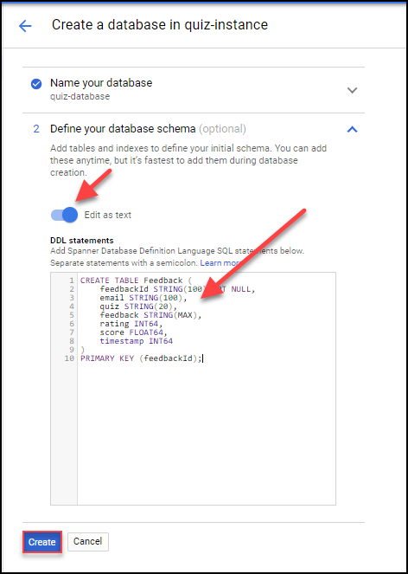

1. In the **DDL statements** text box, type the following SQL statement:
2. CREATE TABLE Feedback (
3. feedbackId STRING(100) NOT NULL,
4. email STRING(100),
5. quiz STRING(20),
6. feedback STRING(MAX),
7. rating INT64,
8. score FLOAT64,
9. timestamp INT64 )
10. PRIMARY KEY (feedbackId);

content_copy

1. Click **Create**.

Write code to persist data into Cloud Spanner

For more information on Cloud Spanner APIs, see [APIs & reference](https://cloud.google.com/spanner/docs/apis).

For information about the specific APIs used in this section, one the left pane of the APIs & reference page, in the APIs and reference section, click **Client libraries** > **Java reference**.

1. Return to the code editor, and move to the insertFeedback(...) method in the **...services/gcp/spanner/SpannerService.java** file.
2. Get a reference to Cloud Spanner.
3. // TODO: Get a reference to the Spanner API
4. SpannerOptions options =
5. SpannerOptions.newBuilder().build();
6. Spanner spanner = options.getService();
7. // END TODO

content_copy

1. Get a reference to the Spanner database via the Database Id.
2. // TODO: Get a reference to the quiz-instance
3. // and its quiz-database
4. DatabaseId db = DatabaseId.of(
5. options.getProjectId(),
6. "quiz-instance",
7. "quiz-database");
8. // END TODO

content_copy

1. Get a reference to the Cloud Spanner Database client.
2. // TODO: Get a client for the quiz-database
3. DatabaseClient dbClient =
4. spanner.getDatabaseClient(db);
5. // END TODO

content_copy

1. Create a new List<Mutation> to reference all the changes that will be made to the database.
2. // TODO: Create a list to hold mutations
3. // against the database
4. List<Mutation> mutations = new ArrayList<>();
5. // END TODO
6. // END TODO

content_copy

1. Add the Mutation that represents an insert against the feedback table, using data from the feedback object.
2. // TODO: Add an insert mutation
3. mutations.add(
4. // TODO: Build a new insert mutation
5. Mutation.newInsertBuilder("Feedback")
6. .set("feedbackId")
7. .to(feedback.getEmail() + '_' +
8. feedback.getQuiz() + "_" +
9. feedback.getTimestamp())
10. .set("email")
11. .to(feedback.getEmail())
12. .set("quiz")
13. .to(feedback.getQuiz())
14. .set("feedback")
15. .to(feedback.getFeedback())
16. .set("rating")
17. .to(feedback.getRating())
18. .set("score")
19. .to(
20. feedback.getSentimentScore())
21. .set("timestamp")
22. .to(feedback.getTimestamp())
23. .build());
24. // END TODO

content_copy

1. Use the database client to write the mutations.
2. // TODO: Write the change to Spanner
3. dbClient.write(mutations);
4. // END TODO

content_copy

1. Save the file.

Write code to use the Cloud Spanner functionality

1. Move to the main(...) method in the backend/ConsoleApp.java file.
2. In the main()method, create a SubscriptionName object representing a new subscription named "worker3-subscription".

This replaces the "worker2-subscription".

// TODO: Create the Pub/Sub subscription name

SubscriptionName subscription =

SubscriptionName.create(projectId,

"worker3-subscription");

// END TODO

content_copy

1. At the point indicated by the comments, create the SpannerService instance.
2. // TODO: Create the spannerService
3. SpannerService spannerService = SpannerService.create();
4. // END TODO

content_copy

1. At the point indicated by the comments, use the spannerService object to insert the feedback into the database and print out a message to the console.
2. // TODO: Insert the feedback into Cloud Spanner
3. spannerService.insertFeedback(feedback);
4. System.out.println("Feedback saved");
5. // END TODO

content_copy

1. Save the file.

Run the web and worker application and test Cloud Spanner

1. Return to the first Cloud Shell window, start the web application.
2. Switch to the second Cloud Shell window, restart the worker application.
3. Preview the Quiz application, click **Take Test** > **Places**.
4. Answer the questions, select the rating, enter some feedback text, and then click **Send Feedback**.
5. Return to the second Cloud Shell window.

You should see that the worker application has invoked the Cloud Spanner API and displayed the message in the console window.

1. Return to the Console. Click **Navigation menu** > **Spanner**.
2. Select **quiz-instance > quiz-database > Query**.
3. To execute a query, in the **Query** dialog, type SELECT * FROM Feedback, and then click **Run query**.

SELECT * FROM Feedback

content_copy

You should see the new feedback record in the Cloud Spanner database, including the message data from Cloud Pub/Sub and the Quiz score from the Cloud Natural Language API.

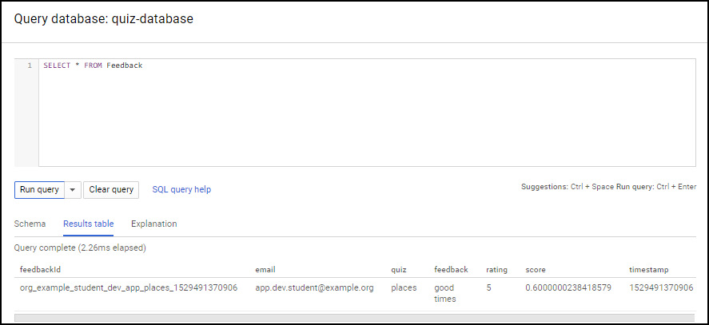

Alternatively, you can view the feedback by clicking **Feedback** in the left pane and clicking the SCHEMA tab to view the schema and the DATA tab to view the submitted feedback.

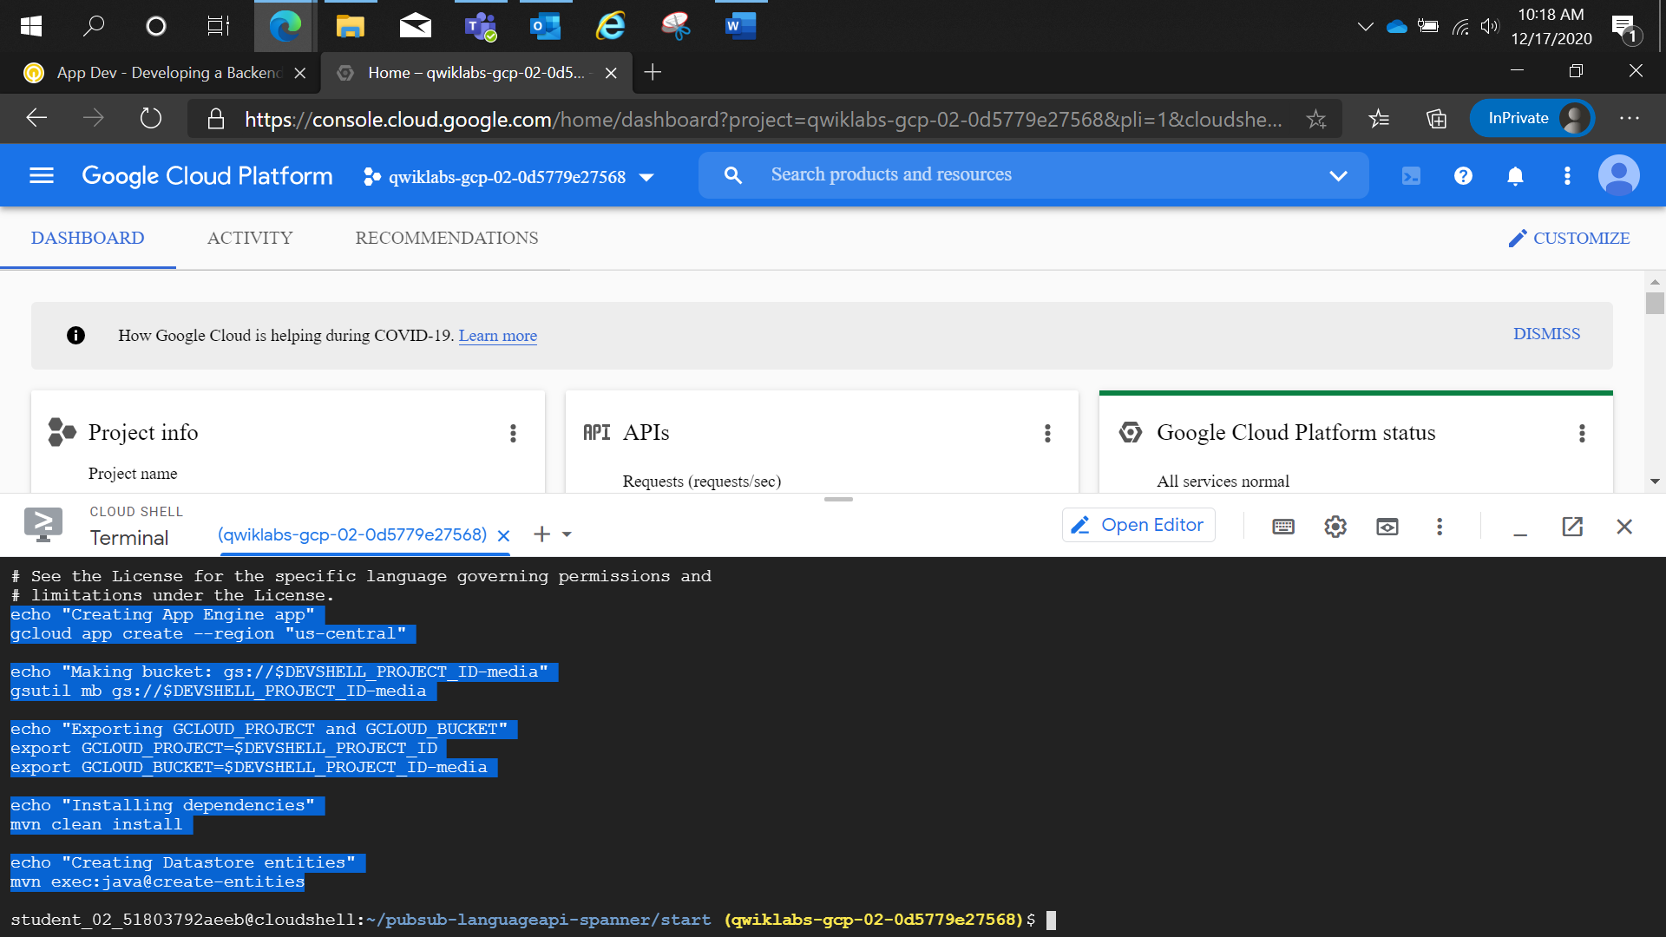

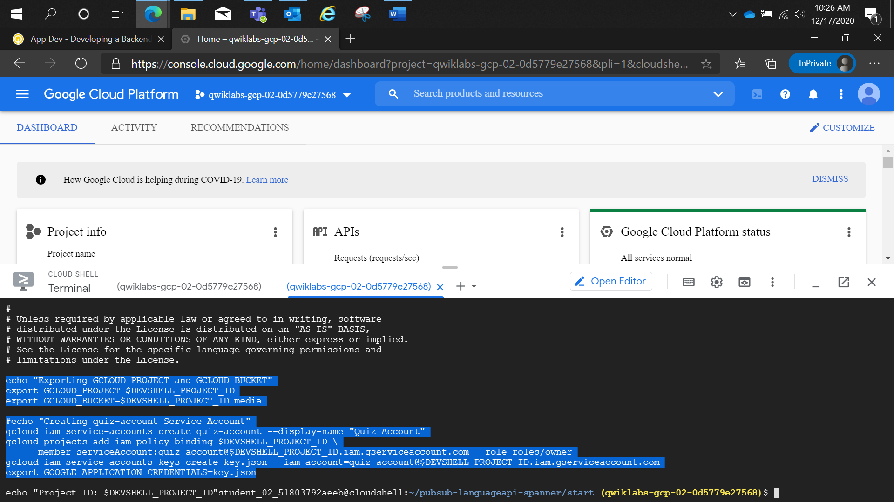

Adding Intelligence:

